

**FPT ACADEMY INTERNATIONAL**

**FPT – APTECH COMPUTER EDUCATION**

**USER GUIDE FOR HAIR CARE SPA WEBSITE**

**I. System Requirement**

|  |  |  |
| --- | --- | --- |
| **No** | **Software** | **Description** |
| **1** | **Operating system** | **Windows 7 or higher** |
| **2** | **Hardware** | **Intel Pentium 4 processor or higher**  **512 Megabytes of RAM or higher** |
| **3** | **Software** | **Visual Studio Code, Dreamweaver** |
| **4** | **Web browser** | **Internet Explorer 11 , Chrome, Firefox, Safari** |

1. **Introduction and website installation**

- This document is created to guide users use the website – Rhythm House effectively. It is advisable that users should read this document before starting to use this website in reality.

- To run *Hair Care Spa* website, users need to do the following steps:

* + - 1. Download the file rar *eProject – Hair Care Spa by Group 4 (FPT Aptech HCM)* via this link:
      2. Extract the file rar: *eProject – Hair Care Spa by Group 4 (FPT Aptech HCM)*

1. Open the folder *eProject*
2. Open *Index.html* file to start the website. Look at figure 1 for illustration

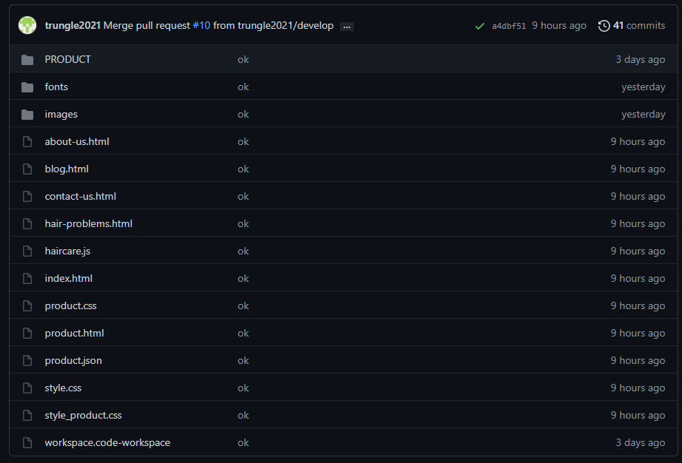

*Figure 1*

1. If done successfully, users will see the Homepage like figure 2 below

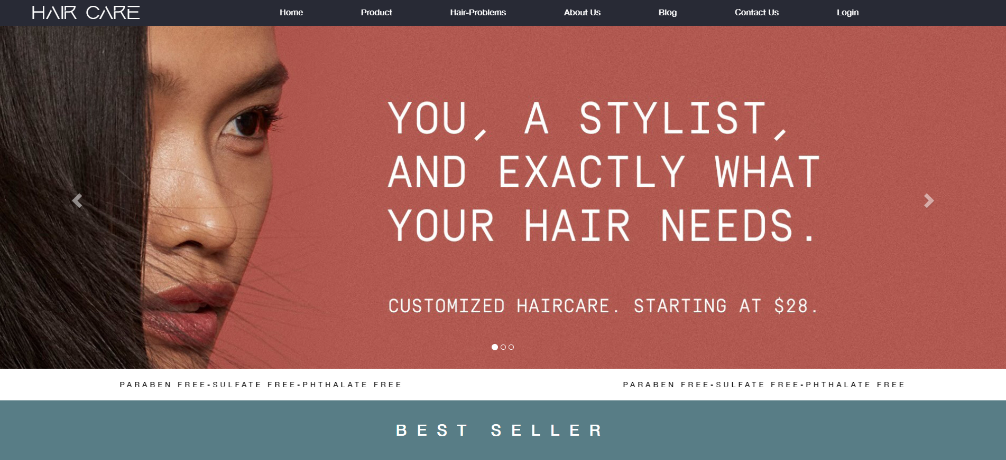

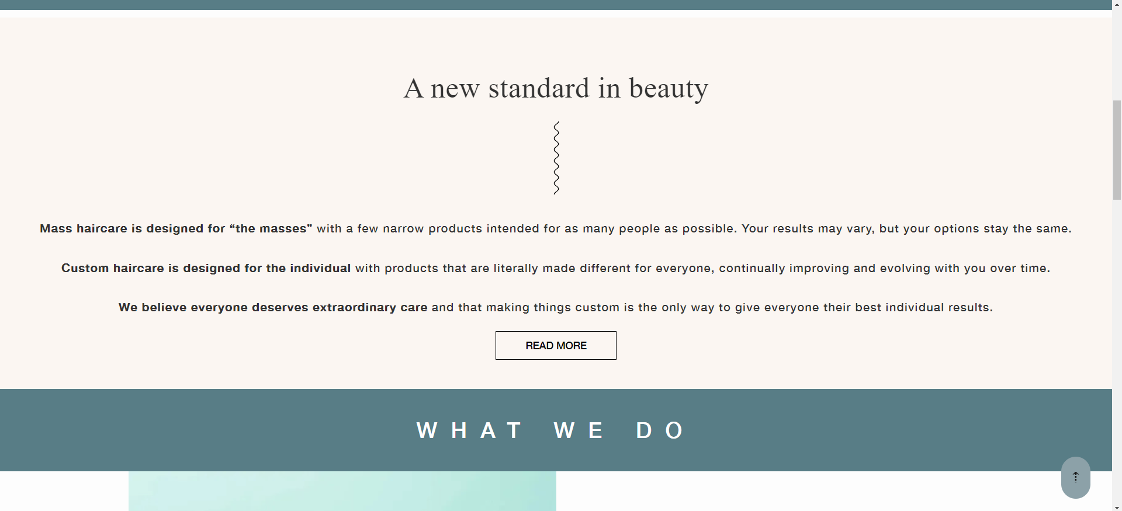

*Figure 2*

1. **Product**

- This webpage allows users to find the information for the products they’re looking for. To get the details of a particular item, users need to click on product image, which will automatically open the information modal for that item. For example, figure 3 illustrates how to get detailed information for every single product.

- Product comparison (figure 4)

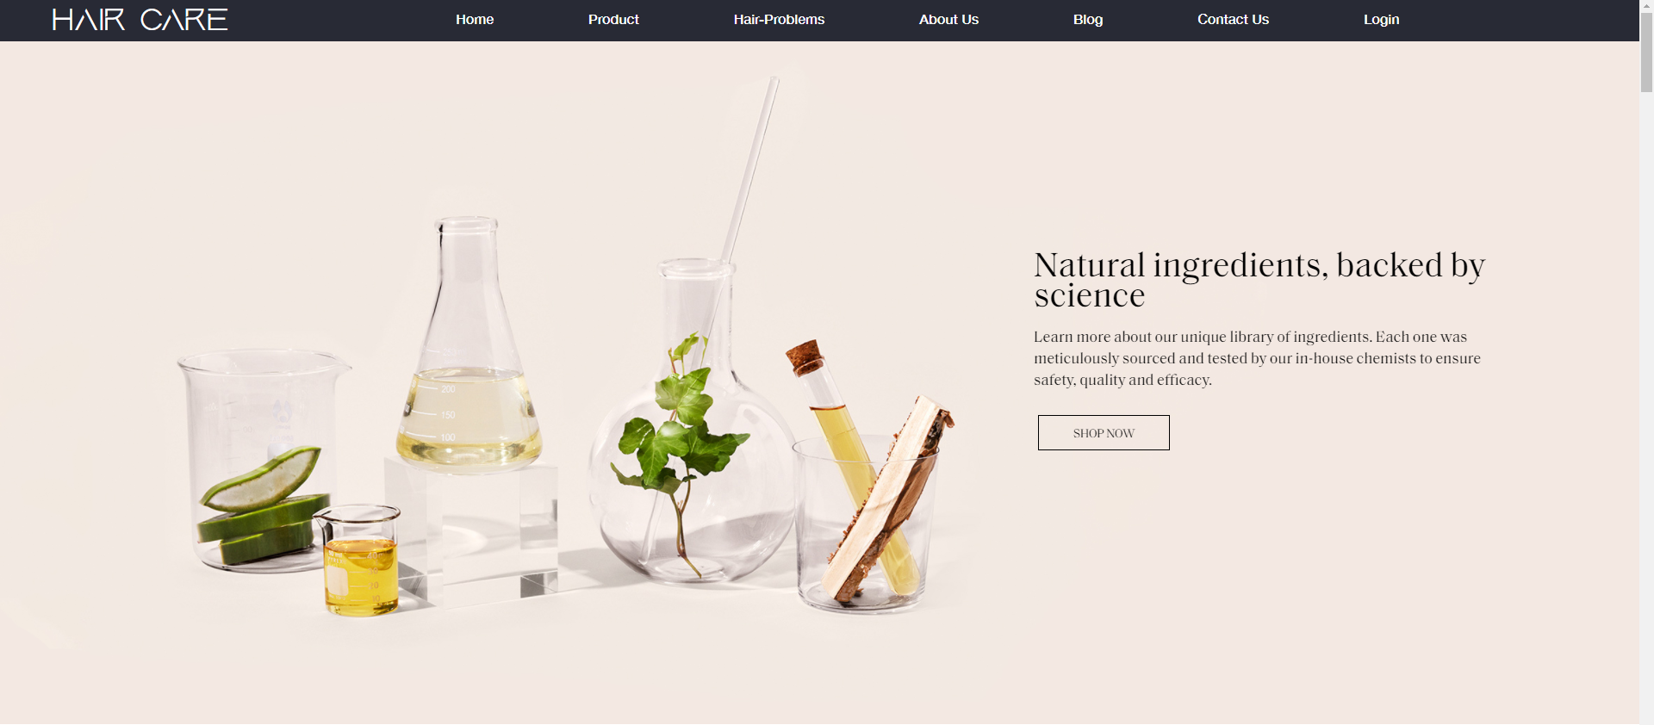

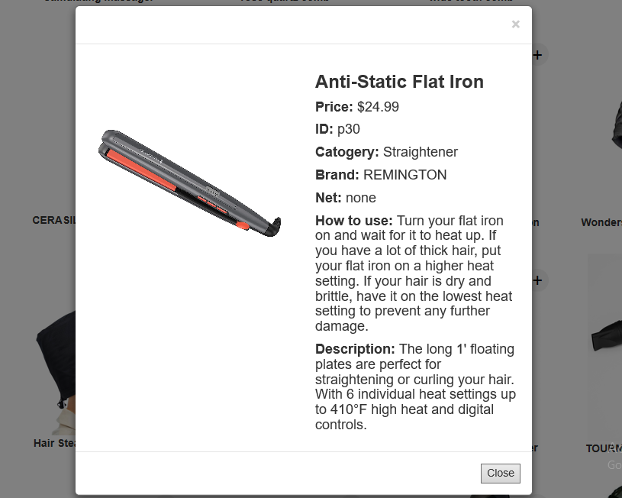

*Figure 3*

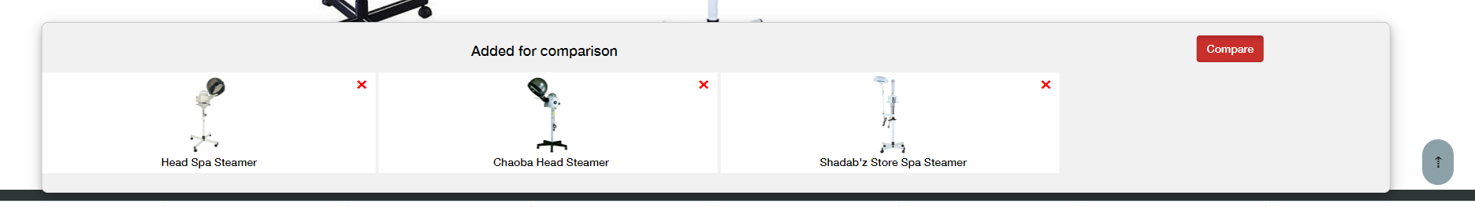

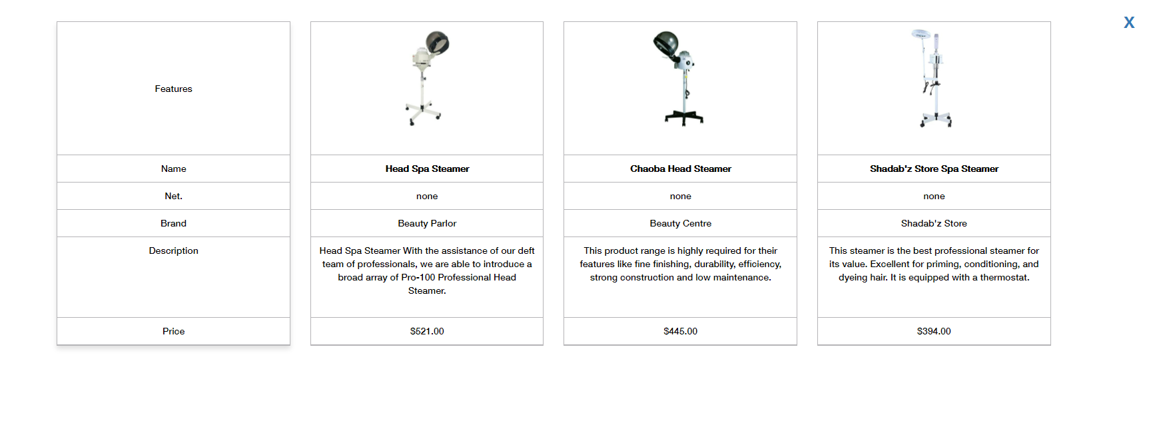

*Figure 4*

- To make it easier for users to find the product as fast as possible, we created to filter option and search bar.

+ As for search bar: To use this function, users need to type the name of a particular product and then press enter. To reset, they need to erase what they typed and press enter.

1. **Login/Register**

- This webpage allows users to sign up new account and login.

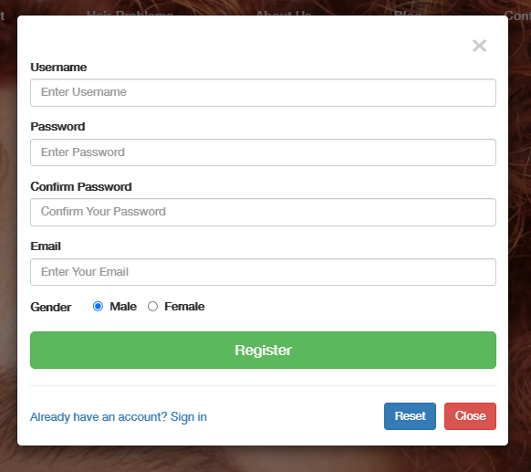

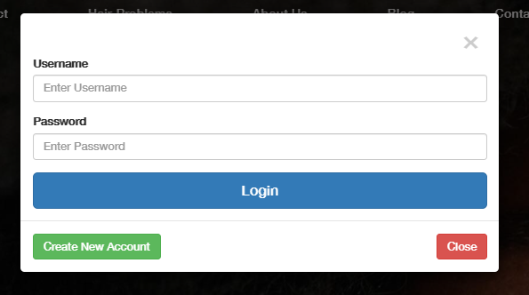

*Figure 5*

1. **Blog**

The blog page displays following information:

* Tips (figure 6).
* Trends (figure 7).
* Latest development (figure 8).

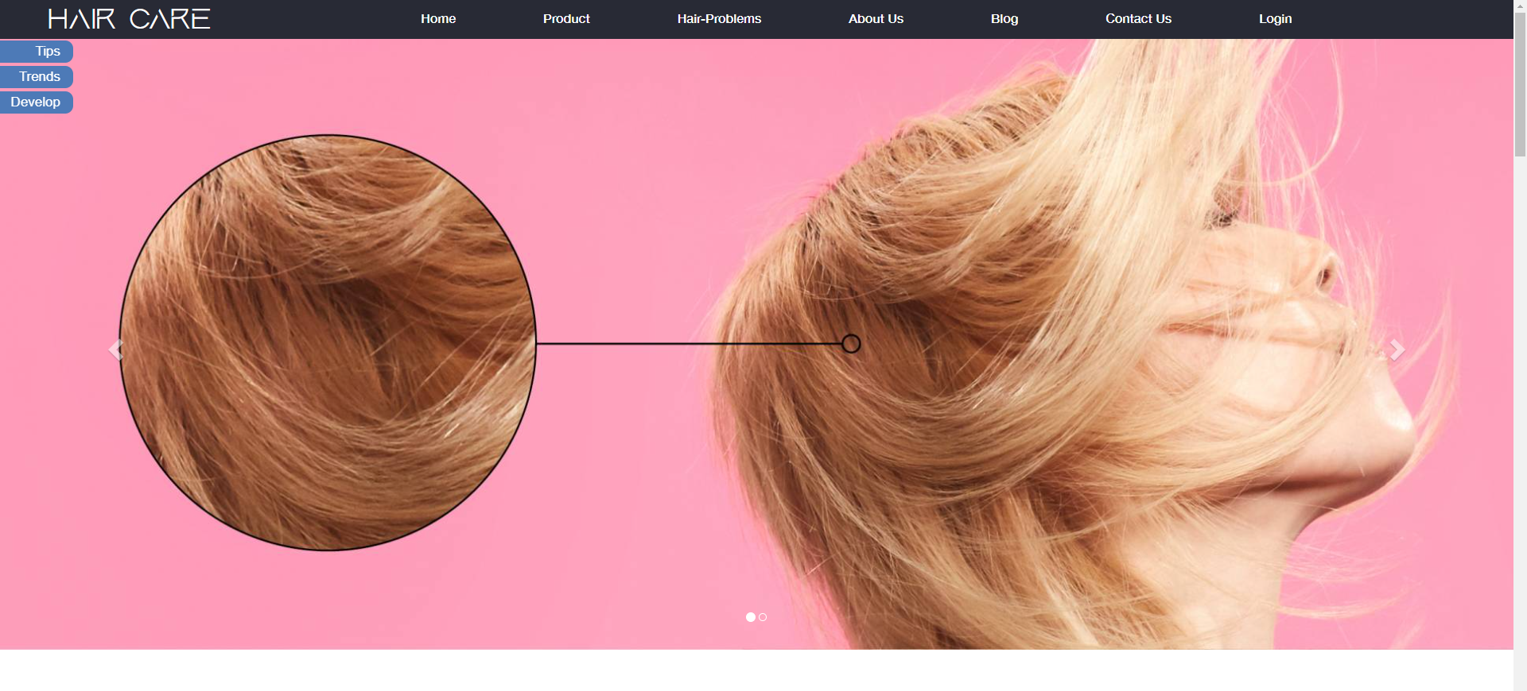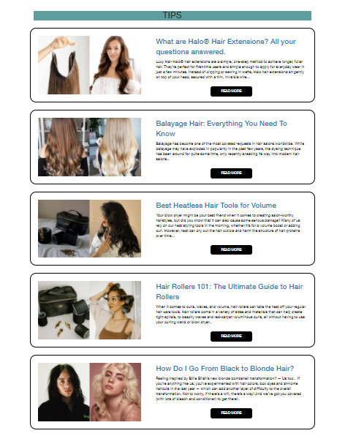

*Figure 6*

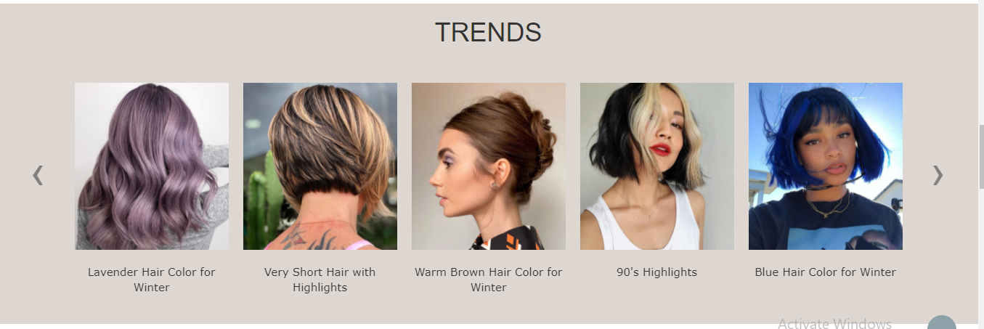

*Figure 7*

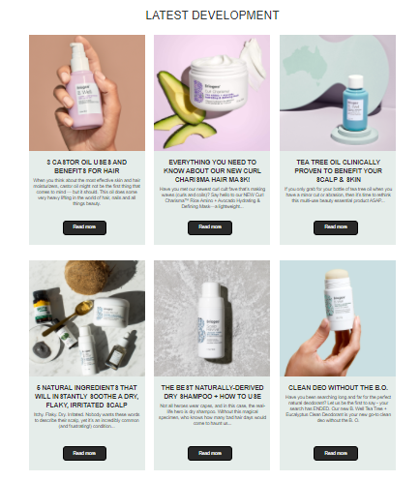

*Figure 8*

1. **About us**

- This page displays our team member.

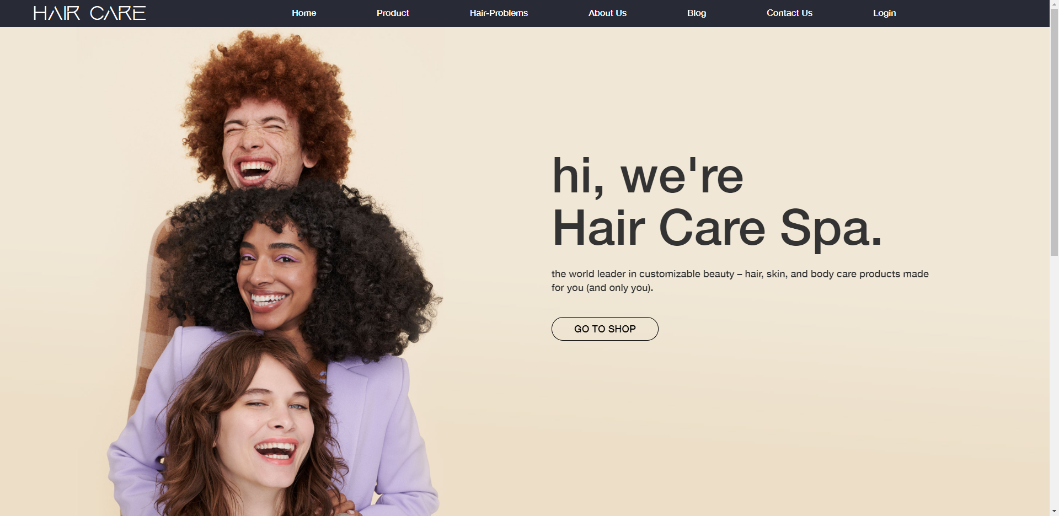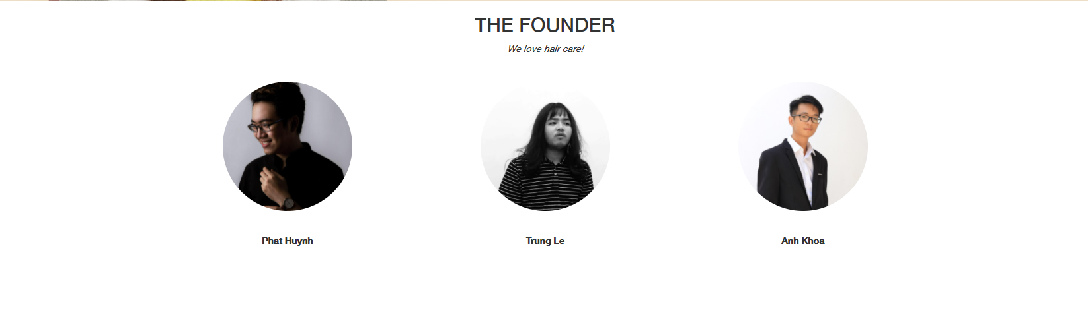

*Figure 9*

1. **Contact us page**

- This page displays contact information: location, telephone number, email and a quick contact form for customer.

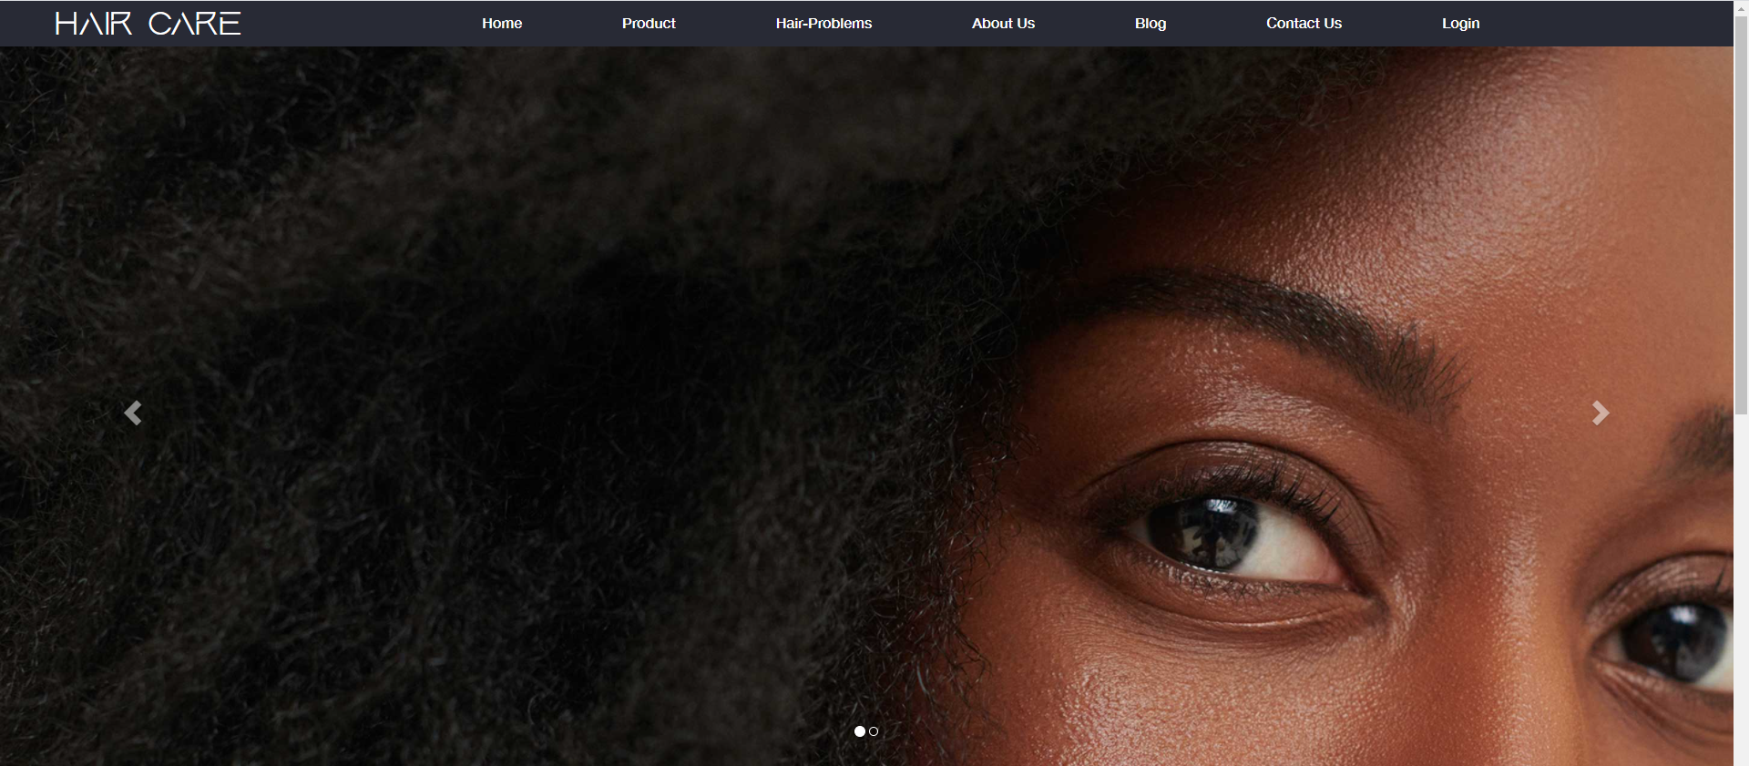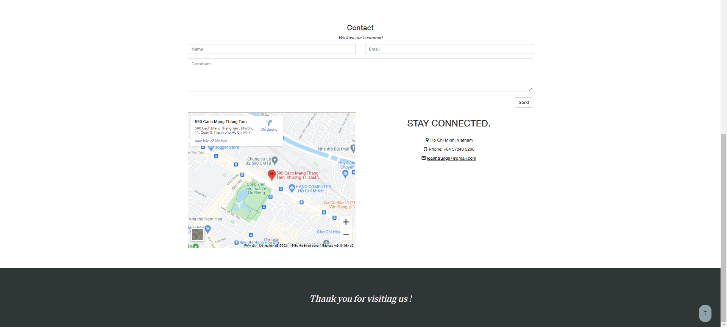

*Figure 10*

1. **Hair prolems page**

* This webpage displays articles about hair problem (figure 11) and treatments at home (figure 12)

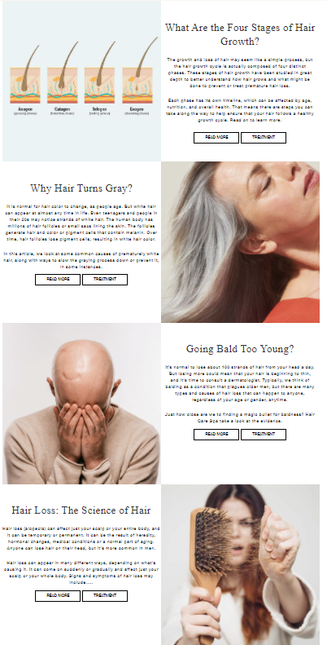

*Figure 10*

*Figure 11*

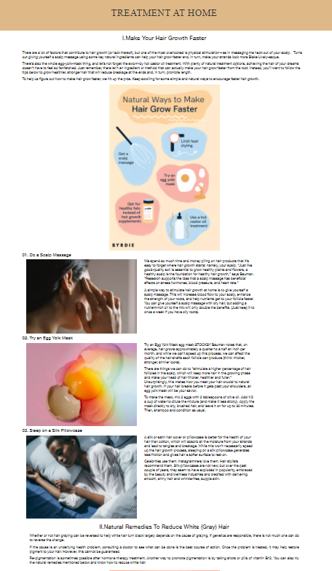

*Figure 12*